ANNUAL ACADEMIC CALENDER
KENDRIYA VIDYALAYA KARAIKUDI
2021-2022

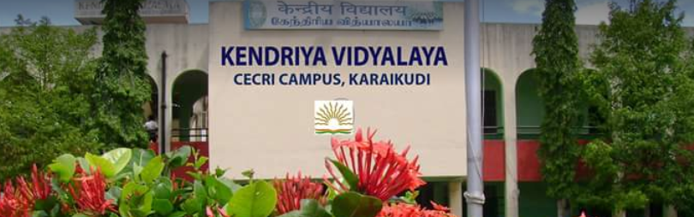
2021
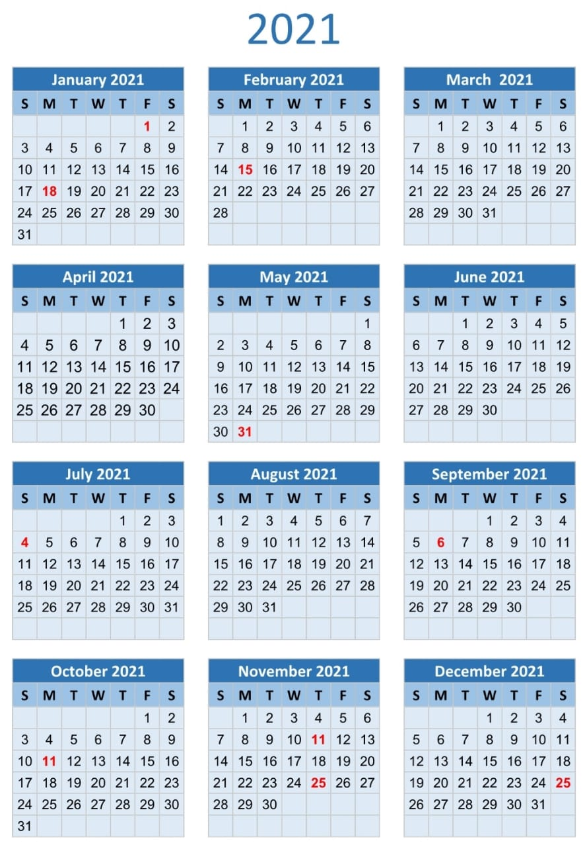
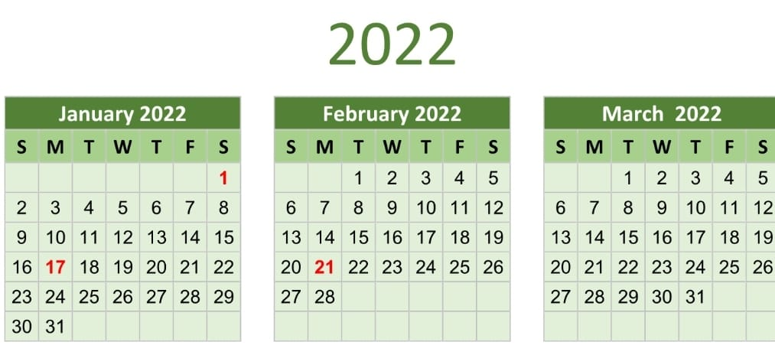

ACADEMIC CALENDER 2021-22

APRIL 2021
LIST OF ACTIVITES PLANNED:
1. Welcome and Beginning of New Academic Session
2. Registration for Class 2nd and above as per Vacancy available.
3. Verification of UBI Data and Collection of Fee for 1st Quarter.
4. Distribution of student Diaries and Form 16 to Employees
5. House Division and Introduction of Calendar of Activities
6. Meeting of Rajbhasha Hindi Committee
7. Distribution of Split-up syllabus.
8. Monthly test for Class X and XII
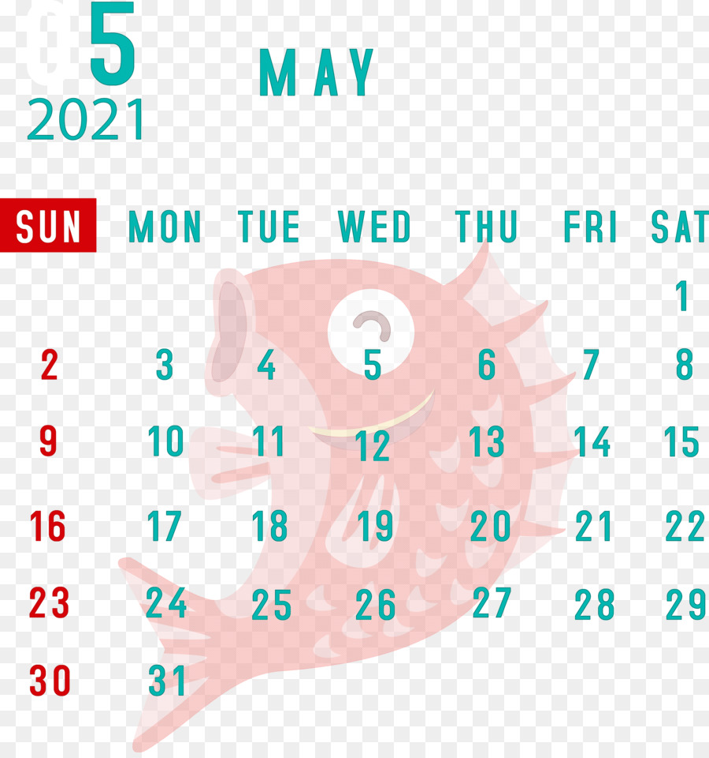

MAY 2021
LIST OF ACTIVITIES PLANNED
- Assignments to Students for vacation ( Summer closing Vidyalayas)
- Planning for maintenance and repair work of building, furniture and Safety Audit Certificate of Vidyalaya building, Fire etc.
- Summer vacation starts (Summer Closing Vidyalayas).

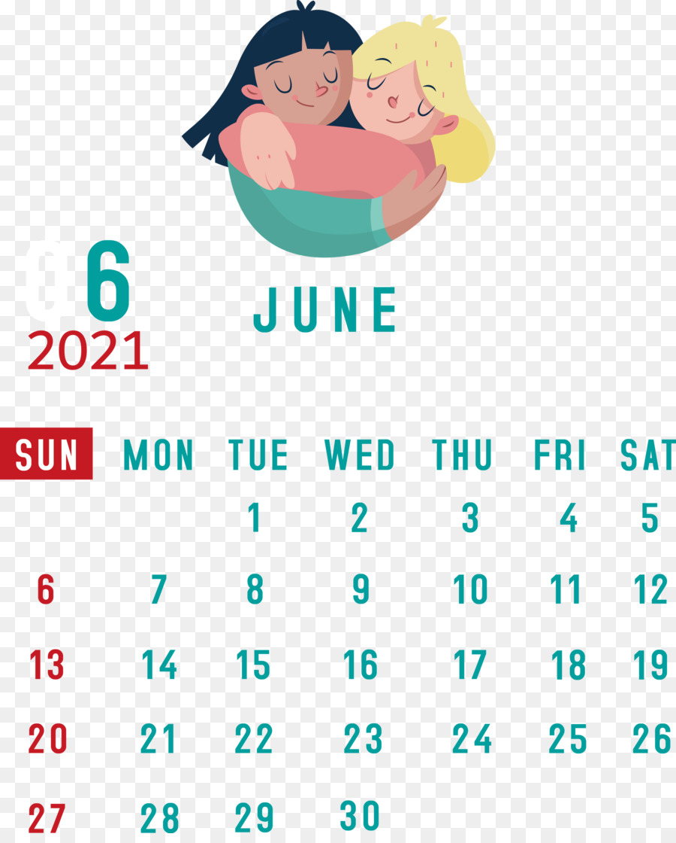

JUNE 2021
LIST OF ACTIVITIES PLANNED:
- Resuming the normal work after vacation ( Summer closing Vidyalayas)
- Verification of UBI data.
- Investiture Ceremony for the House and School Captain/ Students Council.
- Celebration of International Yoga Day.
- Admission for I std.
- Finalization of CBSE results – X &XII.
- Updating TN EMIS Portal.

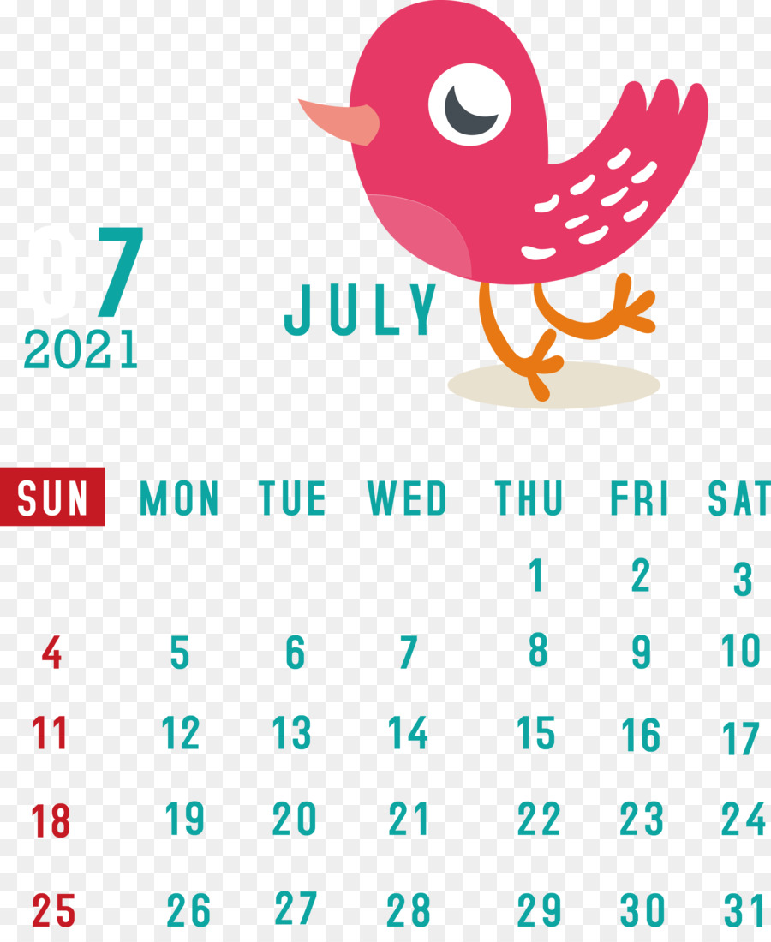

JULY 2021
LIST OF ACTIVITIES PLANNED:
- Collection of Fees for second quarter through UBI.
- Environment/ Plantation/ Book Week/Van Mahotsova.
- Ek Bharat Shrestha Bharat and Science Exhibition at school level.
- Meeting of Rajbhasha Committee.
- Conduct of First Periodical Test.
- Admission on local transfer by KVS.

AUGUST 2021
LIST OF ACTIVITIES PLANNED:
1. Independence Day celebration
2. Celebration of Sanskrit week
3. Ek Bharat Shrestha Bharat parv
4. Health Check-up
5. Conduct of VMC Meeting
6. Parent -Teachers Meeting
7. Conduct of Monthly test for class X & XII

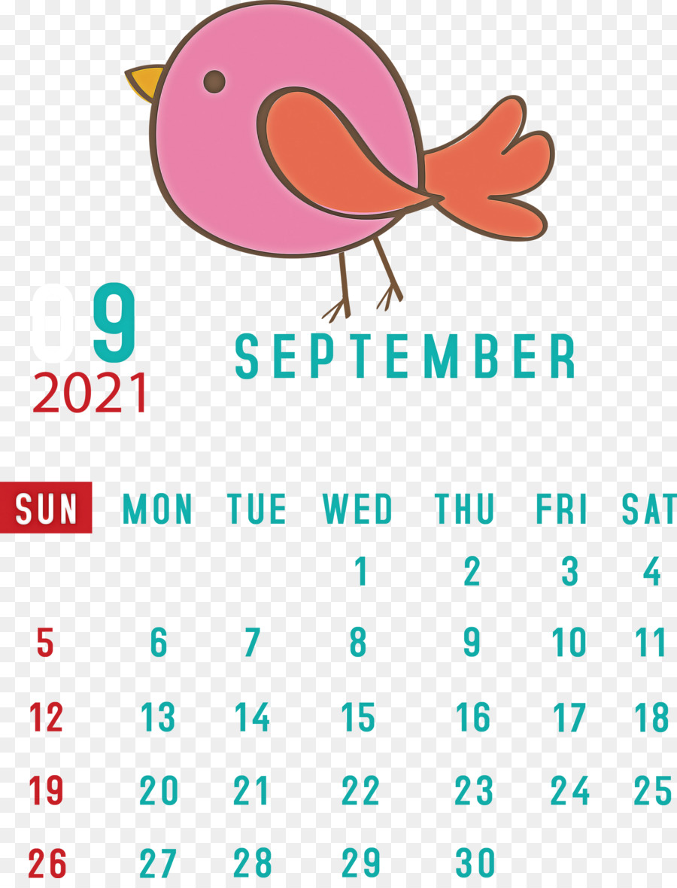
SEPTEMBER 2021
LIST OF ACTIVITIES PLANNED:
- Celebration of Teacher’s Day
- Celebration of Hindi Diwas and Pakhwada
- Maths Olympiad
- Annual Sports Day
- Swachhta Pakhwada
- Periodical test II
- Monthly test for Class X and XII
- Cluster / Regional level Science Exhibition.

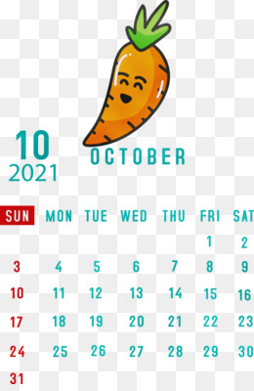
OCTOBER 2021
LIST OF ACTIVITIES PLANNED:
1. Gandhi Jayanthi Celebration/Grand Parent’s Day
2. Collection of fees for third quarter through UBI.
3. Half-Yearly Examination for summer stations.
4. Vigilance Awareness Week.
5. Celebration of Rashtriya Ekta Diwas
6. Meeting of Rajbhasha Committee
7. Conduct of National Children Science Congress.
8. Conduct of Vidyalaya level scout & guide / Cubs & Bulbul camp.
9. Celebration of Dusshera.
10. Autumn break ( Assigning homework to students)

November 2021
List of Activities Planned:
- Children’s Day Celebration
- National Education Day (11th November)
- Celebration of Constitution Day ( 26th November)
- Celebration of Communal Harmony Week
- Conduct of First Practice Test/ Pre-Board

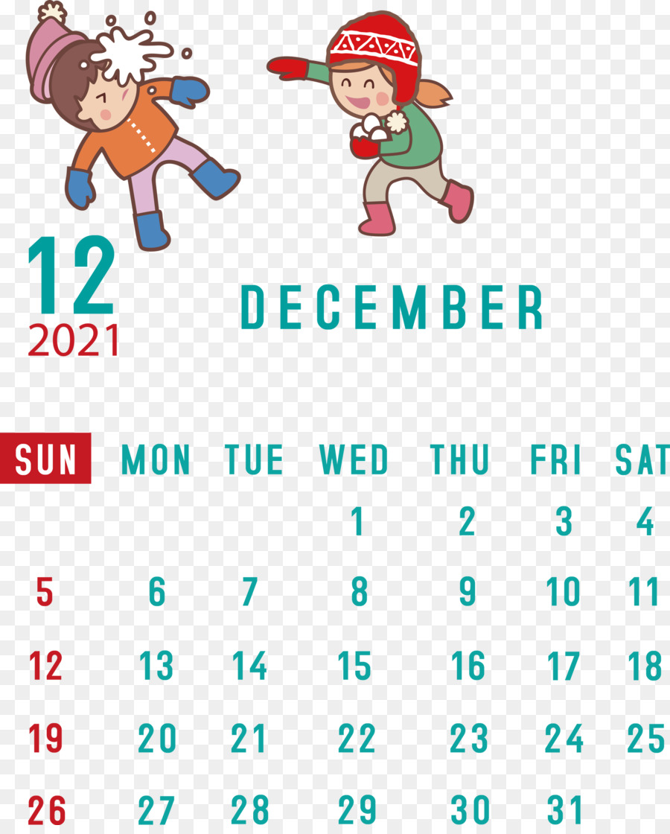

December 2021
List of Activities Planned:
- KVS Foundation Day ( 15th December)
- Conduct of VMC Meeting
- Assignment to students for Winter Break

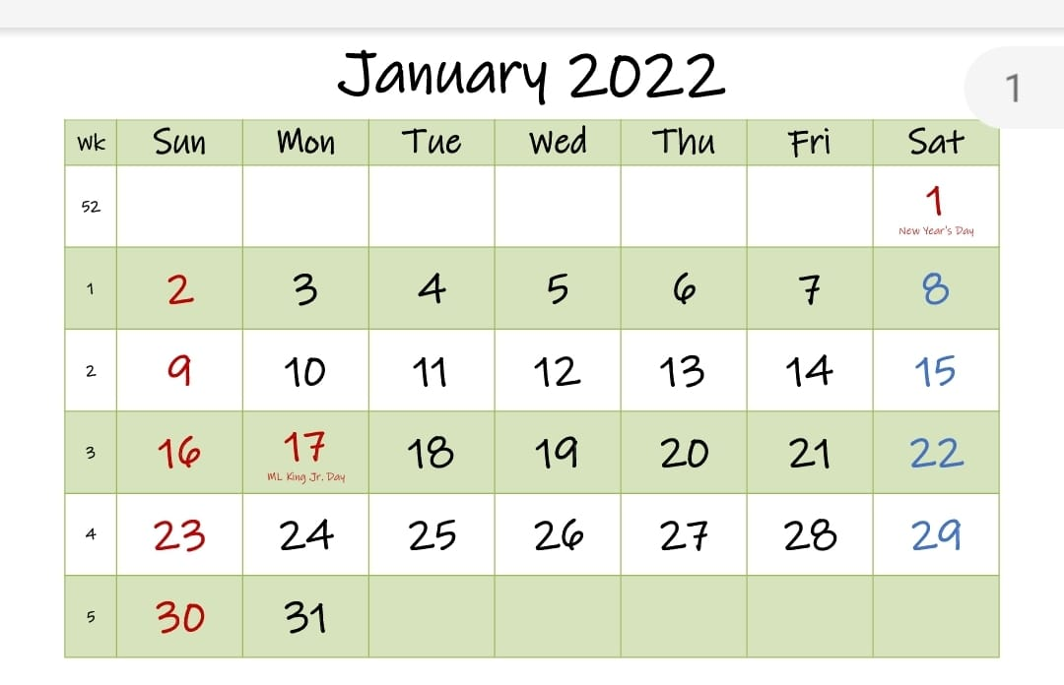
JANUARY 2022
List of Activities Planned:
1. Republic Day Celebration
2. Periodical Test III for summer station
3. Parent-teacher Meeting
4. Meeting of Rajbhasha Committee
5. Second Practise test/Pre-Board test for X&XII
6. Structured Revision for class X and XII
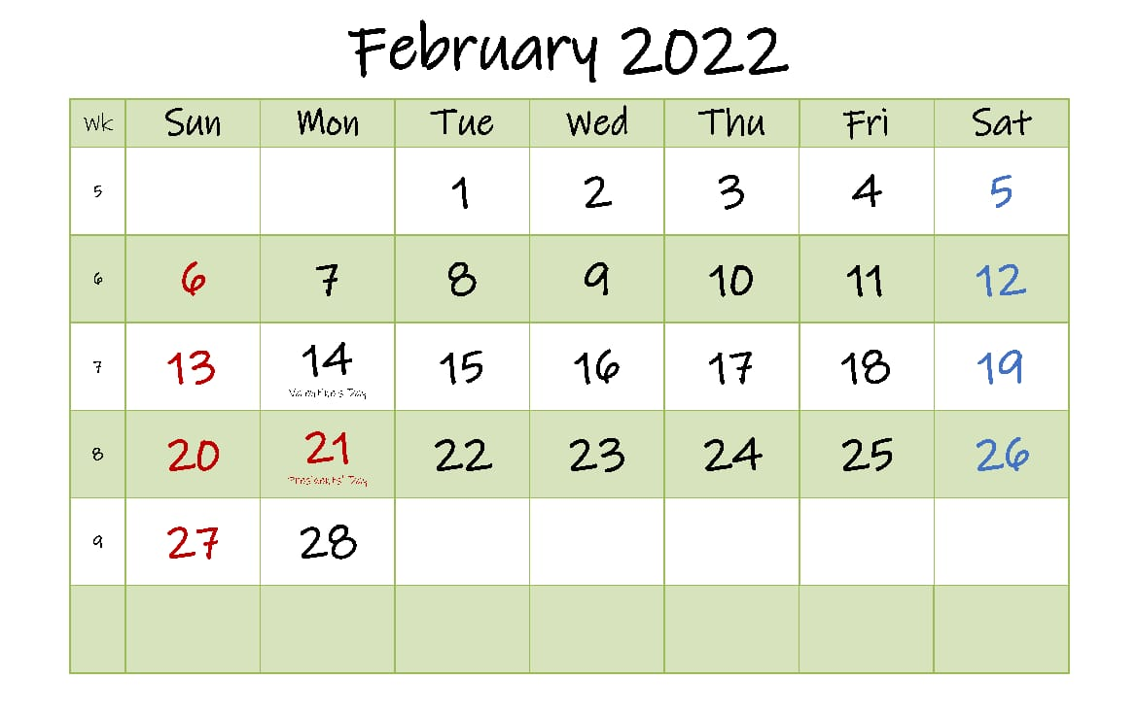
FEBRUARY 2022
LIST OF ACTIVITIES PLANNED:
1. Notification and registration for admission to class 1st and other classes
2. Interview for Contractual appointments
3. Conduct of VMC meeting in first week
4. Cubs and Bulbuls Utsav/ Celebration of Thinking Day
5. Health Check-up
6. Structured Revision for all classes
7. Conduct of CBSE Practicals.
8. Online admission starts

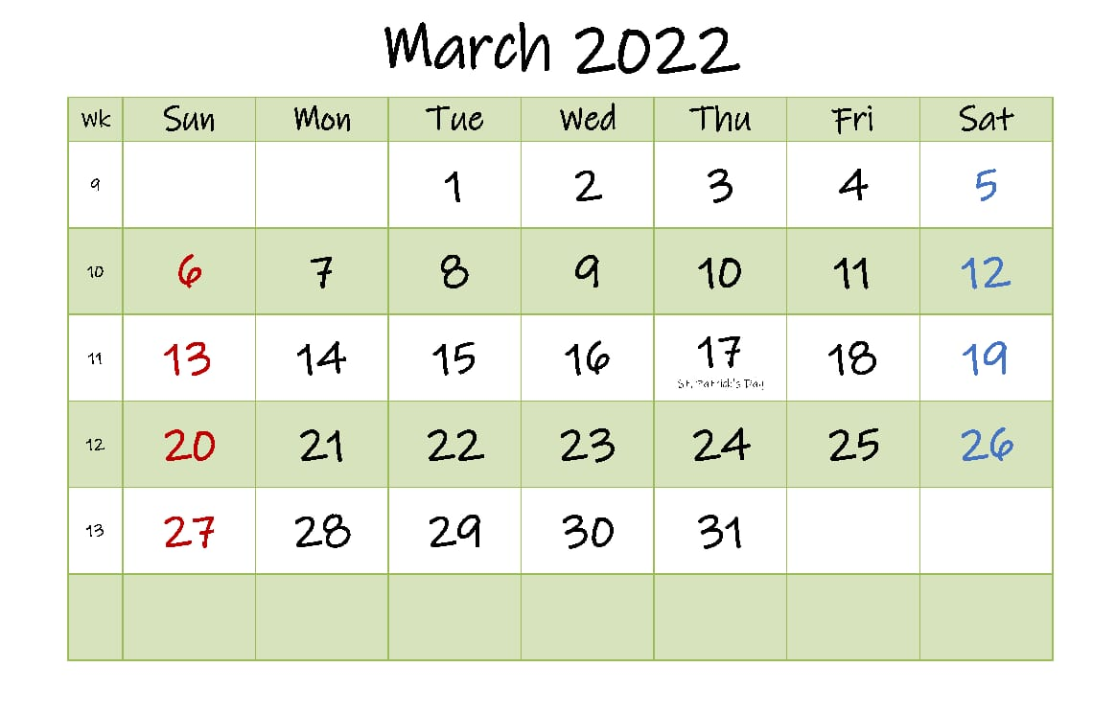
MARCH 2022
LIST OF ACTIVITIES PLANNED:
- Board Examination and Session Ending Examination for all classes
- Printing of Student’s diaries and Teacher’s diaries for next session
- Planning for the next session
- Declaration of result
- Admission as per KVS Schedule
- Framing of Time-table for new session
- Finalization the list of class teachers and co- class teachers.
- Preparation of Annual VVN budget
- Preparation of the calendar of CCA, Sports activities & AAC.
- Physical Verification of Stock
- Addition of new admissions in UBI
- Class one admission

